Experiment 15: Information Gathering Using theHarvester in Kali Linux
Aim
To perform information gathering using theHarvester tool in Kali Linux to identify publicly available information, such as email addresses, subdomains, and hostnames associated with a target domain.
Algorithm
- Start Kali Linux and open the terminal.
- Check whether theHarvester is installed.
- Select a domain that you own or have permission to investigate.
- Execute theHarvester with a supported public data source.
- Collect publicly available email addresses, subdomains, and hostnames.
- Observe the output and record the results.
Commands and Uses
1. Check theHarvester installation
theHarvester -h
Use: Displays help information and available command-line options.
If it is not installed, try:
sudo apt update
sudo apt install theharvester -y
2. Gather information about a domain
Use a domain you own or are authorized to assess. For example, example.com is a reserved demonstration domain.
theHarvester -d example.com -b crtsh
Use:
- -d specifies the target domain.
- -b specifies the data source.
- crtsh queries Certificate Transparency information where supported by the installed version.
3. Save the results to a file
theHarvester -d example.com -b crtsh -f results
Use: Saves the gathered results in a report file, where supported by the installed version.
Sample Output
The exact output depends on the data source and the information publicly available.
*******************************************************************
* theHarvester
*******************************************************************

[*] Target: example.com
[*] Searching public sources...

[*] Emails found: 0
[*] Hosts found: 0

[*] Search completed.
Note: This is illustrative output, not a live scan. The number of results may vary.
Use of theHarvester
- Collects publicly available information about domains.
- Helps identify email addresses and subdomains.
- Supports reconnaissance during authorized security assessments.
- Helps security teams understand their public exposure.
- 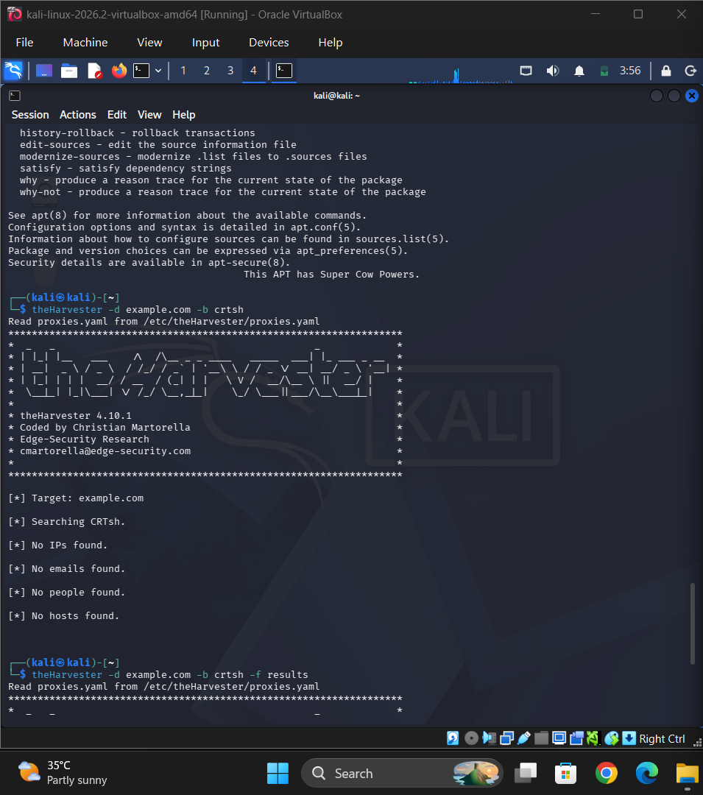

Result
TheHarvester was used to demonstrate information gathering from public sources in Kali Linux. The tool can help identify publicly exposed domain-related information for security assessment.
Safety note: Perform information gathering only on domains you own or have permission to assess.

